*A project report on*

**CAR ADVISORS –**

**YOUR AUTO MOBILE COUNCILLOR**

**TEAM MEMBERS-**

**ANIRUDHA AGARWAL (20BCE1738)**

**SIDDHARTH THAKUR (20BCE1144)**

**PRAKUL VYAS (20BCE1273)**



**NOVEMBER, 2021**

**CERTIFICATE FROM GUIDE**

This is to certify that this project entitled “CAR ADVISORS” submitted in partial fulfilment of the degree of B.Tech to Vellore Institute of Technology, Chennai, done by

***ANIRUDHA AGARWAL (20BCE1738), SIDDHARTH THAKUR (20BCE1144), PRAKUL VYAS (20BCE1273),***

It is an authentic work carried out by them under my guidance. The matter embodied in this project work has not been submitted earlier for award of any degree or diploma to the best of my knowledge and belief.

Signature of the student Signature of the Guide

Date: 15 November 2021

**DECLARATION BY THE STUDENT**

We **ANIRUDHA AGARWAL (20BCE1738), SIDDHARTH THAKUR (20BCE1144), PRAKUL VYAS (20BCE1273)** hereby declare that this project report entitled **CAR ADVISORS** has been prepared by us towards the partial fulfilment of the requirement for the award of the Bachelor of Technology (B.Tech) Degree under the guidance of **Ms. Mekhala Antony**.

We also declare that this project report is our original work and has not been previously submitted for the award of any Degree, Diploma, Fellowship, or other similar titles.

Name: ANIRUDHA AGARWAL (20BCE1738), SIDDHARTH THAKUR (20BCE1144), PRAKUL VYAS (20BCE1273)

Date: 15th November 2021

**ACKNOWLEDGEMENT**

We would like to express our special thanks of gratitude to our teacher Ms. Mekhala Antony Ma’am who gave us the golden opportunity to do this wonderful project on the topic Car Advisors, which also helped us in doing a lot of Research and we came to know about so many new things we are really thankful to you.

We would like to express our gratitude towards our parents and our fellow classmates of Vellore Institute of Technology, Chennai and people who have willingly helped us out with their abilities for their kind cooperation and encouragement which help us in completion of this project.

Thank You.

**TABLE OF CONTENTS Page No.**

* **ABSTRACT**…………………………………………………………………………......6
* **INTRODUCTION**…………………………………………………………………........7
* **BACKGROUND**…………………………………………………………………….......8
* **PROBLEM STATEMENT**………………………………………………………..……9
* **CONCEPT GENERATION**……………………………………………………….......10
* **MINDMAP**……………………………………………………………………………...12
* **METHODOLOGY**…………………………………………………………………......13
* **UNDERSTANDING OUR CUSTOMERS**……………………………………………16
* **MARKET CONDITIONS**………………………………………………………….......17
* **INDUSTRY SCANNING**…………………………………………………………..…..18
* **VECHILE SCRAPPAGE POLICY**……………………………………………….......19
* **TECHNOLOGY TRENDS**………………………………………………………….....20
* **TOOLS-**
* **SELECTION MATRIX**……………………………………………………......21
* **BUSINESS MODEL CANVAS**……………………………………………......21
* **LEAN MODEL**………………………………………………………………....22
* **REVIEW OF LITERATURE**……………………………………………………..........23
* **PRODUCT PROTOTYPE**………………………………………………………….…..27
* **MINIMUM VIABLE PRODUCT**………………………………………………….…..30
* **BUDGET**…………………………………………………………………………….......31
* **FUNDING PLAN**…………………………………………………………………….....32
* **FUNDING OPTIONS**……………………………………………………………..........33
* **COST AND REVENUE**………………………………………………………………...34
* **MARKETING PLAN**…………………………………………………………………..35
* **CUSTOMER CENTRIC**………………………………………………………….........36
* **SWOT ANALYSIS**……………………………………………………………………..37
* **COMMERCIAL**………………………………………………………………………..38
* **VISION AND MISSION**…………………………………………………………….....39
* **CONCLUSION**………………………………………………………………………....40
* **BIBLIOGRAPHY**……………………………………………………………………....41

**ABSTRACT**

Car customers even though in the creamy layer of our country are facing the same problems which existed a century ago like getting biased opinion about a car from employees of car dealerships, not getting all necessary facts and information, they have to visit several different dealerships for inquiring information and taking test drives. In tier 2 and tier 3 many car makers don’t have authorized dealerships, so car buyers from these cities have to travel for a couple of cars to other cities for having hands on experience of cars. As a solution to these problems we have come up with an idea Car Advisors. Through this people will get unbiased opinion, they don’t have to visit several dealerships for different cars, travelling for couple hours can be reduced to few mins for tier 2 and tier 3 cities customers. Also customers can even rent the car before buying so that they can finalize the decision without any confusion, hesitation and get rid of regret that they might feel in the future after buying the car.

**INTRODUCTION**

* When you think of the very first car, what do you imagine? While some of the very first cars were powered by steam engines, dating back to the 1700s, these first cars didn’t have windshields, doors, turn signals, or even a round steering wheel – a far cry from what we’ve become accustomed to. In the late 80’s and early 90’s keyless entry systems, electric doors and windows, sunroofs and CD players began to be standard features. This is about the time when technology became a big selling point. This brings us to modern-day cars with Bluetooth, hard drives, advanced safety systems, GPS, Wi-Fi and even the ability to parallel park themselves.
* There has been drastic advancement in the car technology but there is very little improvement in the car buying process which involves car dealerships with no/little advancement in technology, complex taxation and rules, salesmen giving biased opinion about the cars of their employer’s company, confusion, spending much more time and money than needed in deciding which car and variant to buy. To overcome the above mentioned problems we have come up with an idea i.e. Car Advisors.

**BACKGROUND**

* The idea is to have showrooms as multi storey buildings where we will keep all cars of all segments (hatchback, sedan, suv, mpv) available in display as they are present currently in car dealerships. But these car showrooms/dealerships only have their company’s cars in display. We will have multiple companies’ models for display at our showrooms where our consultants who will be automotive experts will be suggesting customers about the cars as per their needs and budget by stating facts and giving unbiased opinion about every car as they are employees of Car Advisors unlike salesman of various company dealerships.
* Also customer will be able to do test drive, get experience and information about different cars at the Car Advisors showrooms. Even they can rent the car for few days so that they can have more insights about the car. This is done so that customers need not visit different companies dealerships to inquire about cars, it will save their time, efforts and money.
* Also in showrooms we will be having much needed kids recreational area so that parents and kids both get a good experience at Car Advisors as kids would indulge themselves in playing which will be under supervision so that parents would feel relaxed and take good decisions unlike the present situation.
* Cars would be segregated according to their price and segment. Customers with budget for cars less than 10 lakh will be given different services in terms of ambience and comfort than customers having budget more than 10 lakh. Also services and experience will be better for costlier car customers. The most important aspects for us will be customer feedback and satisfaction.

**PROBLEM STATEMENT**

The objective is to have offline showrooms across various cities in India and in other countries which have a good car market. In these showrooms, cars of all carmakers will be available where automobile industry experts (employees of CarAdvisors) will be advising the car buyers about the cars by giving all relevant stats and unbiased opinion.

**CONCEPT GENERATION**

* **Brainstorming**

Knowing very well the customer requirements, we henceforth sat for a brainstorming session within our group and we came up with a mind map incorporating all functions and ideas for the product. We used the idea of mind map to clearly lay down our ideas and creativities using which we can develop our concepts.

* **MINDMAP**

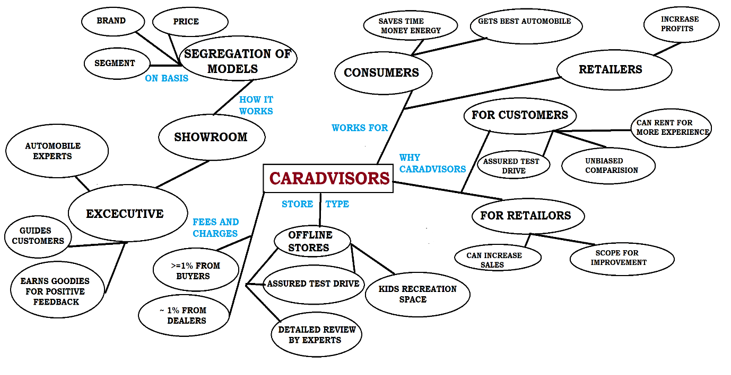

**The list of cars sales in India (individual states) in year 2018-19**

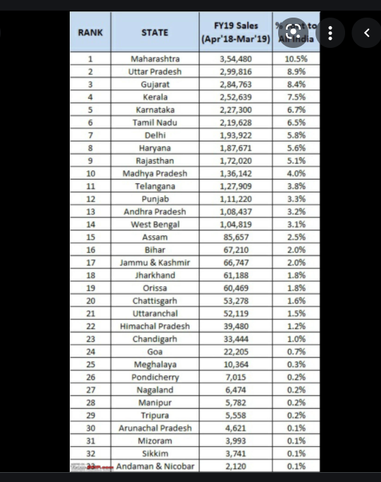

The information depicts the state wise annual sales of cars. Using this information we will be focusing on states according to their ranks for opening showrooms across various cities.

States with more sales will be given preference and shall be having more showrooms to get a good chunk of customers present in India.

**METHODOLOGY**

**Customer Requirement and Statements**

1. I want the best car available in the market according to my needs and budget.
2. I want to test drive cars, these online sites do not offer that.
3. The process of selecting and buying the car is a tedious task.
4. I want an unbiased opinion of an expert during whole process.
5. I bought the wrong car because of wrong advice.
6. I was not told of long term cost of the car and now I am not able to bear the cost.
7. Same features were offered in much cheaper car than the car I own but I didn’t knew that at the time of buying the vehicle.
8. These salesmen just show their company’s car as superior to their competitors.
9. They don’t tell the real difference between the other cars available in the same segment and their car.
10. I want cars of all carmakers available under one roof and an unbiased expert opinion so that I can compare the features, cost and test drive without going to different places.

**UNDERSTANDING OUR CUSTOMERS**

* We had conducted a survey about car buying process and we got 55 responses in it and these are the responses-

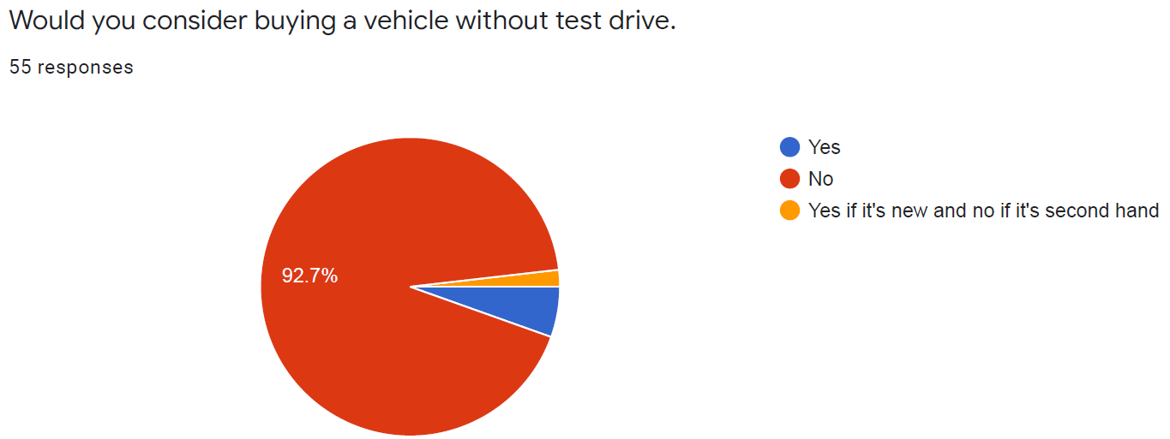

In this question approximately 93 percent of people want to take test drive of a car before buying it.

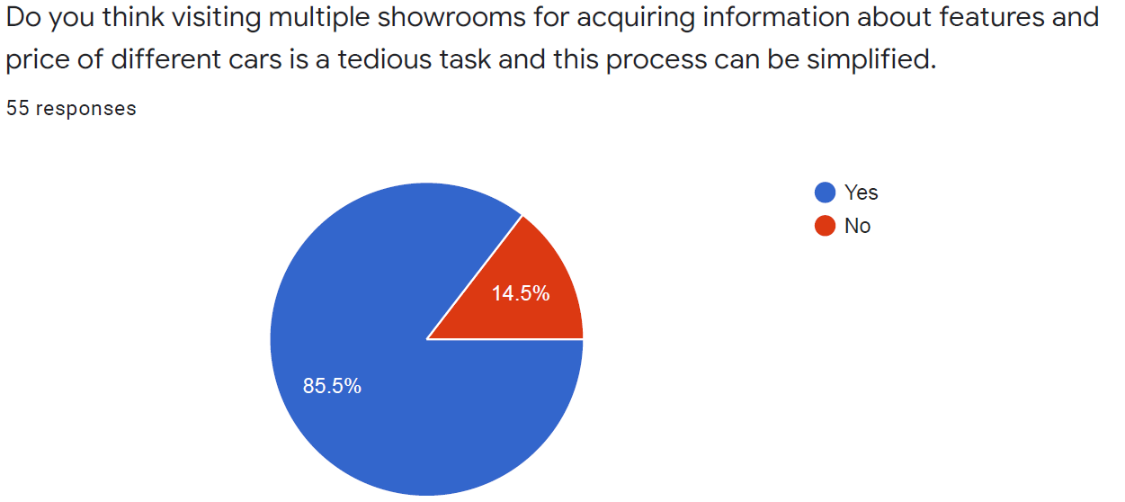

In this question approximately 85 percent of people feels difficultly in visiting different showrooms and they want an easier process.

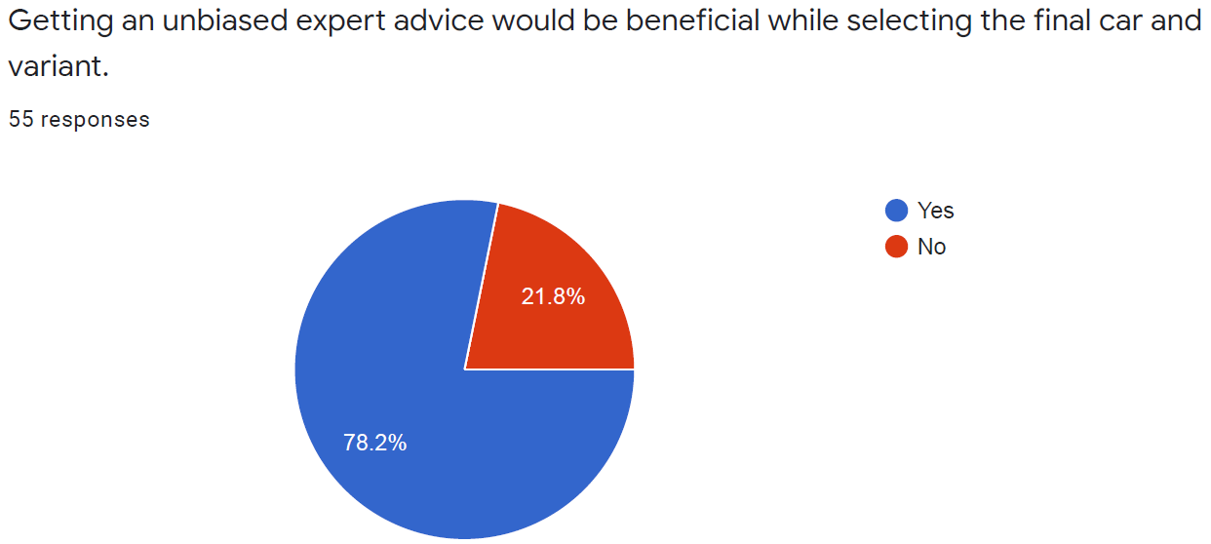

In this question 78 percent of people want unbiased expert advice for selecting their car.

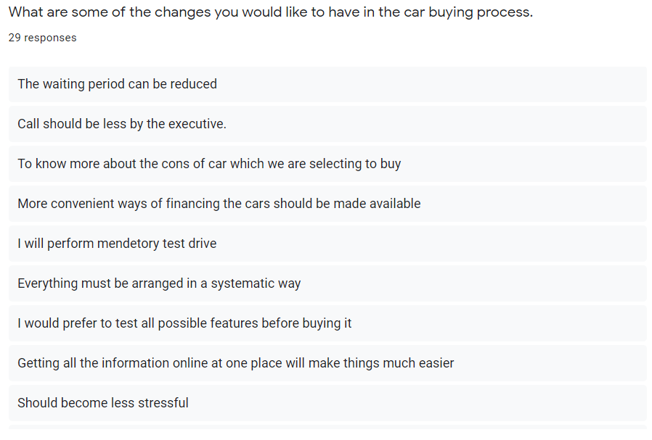

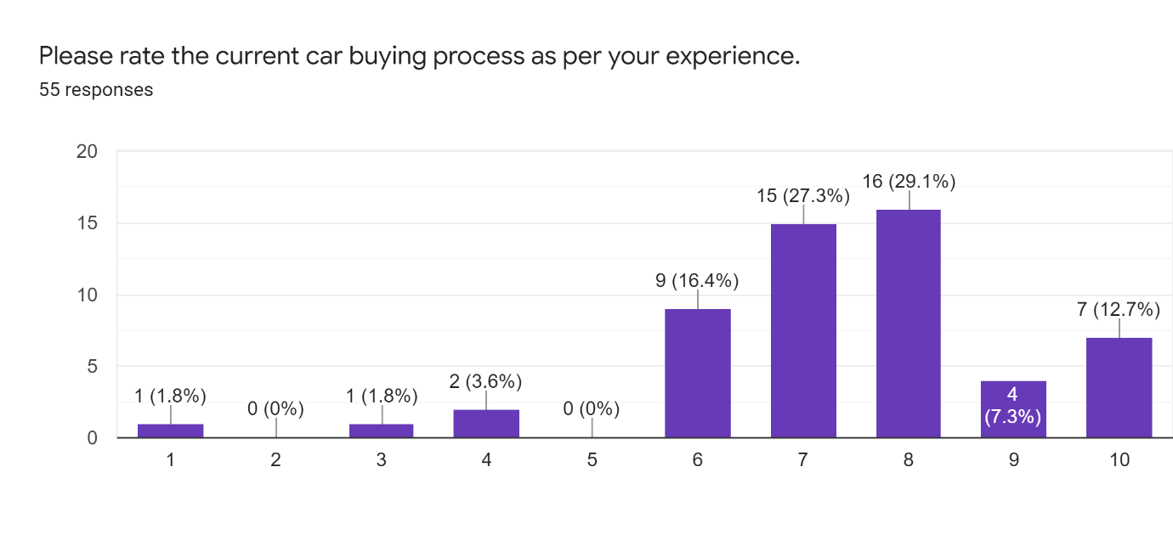

**MARKET CONDITIONS**

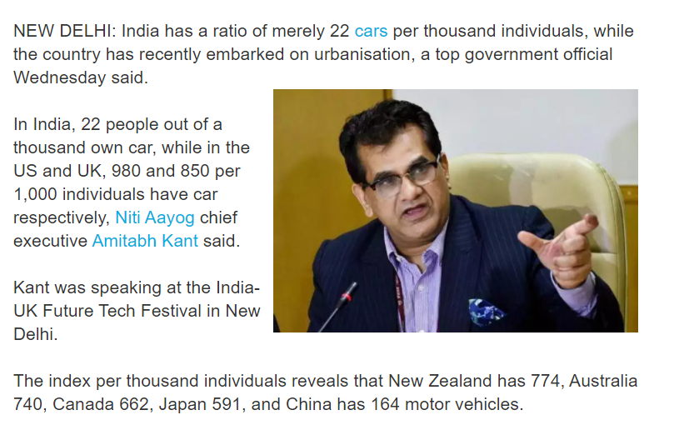

* China is the top country by car sales in the world. As of 2020, car sales in China was 20.2 million units that accounts for 38.33% of the world's car sales.
* The top 5 countries (others are Japan, the United States of America, Germany, and India) account for 62.19% of total sales. The world's total car sales was estimated at 52.6 million units in 2020.
* In India, 22 people out of a thousand own car, while in the US and UK, 980 and 850 per 1,000 individuals have car respectively.
* The International Energy Agency (IEA) finding suggest that the passenger car ownership in India will grow by 775% over the next two decades with 175 cars per 1,000 people in 2040.
* The index per thousand individuals reveals that New Zealand has 774, Australia 740, Canada 662, Japan 591, and China has 164 motor vehicles.

**INDIAN CAR SALES DISTRIBUTION**

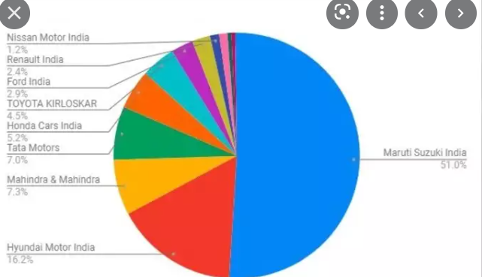

**INDUSTRY SCANNING**

* Maruti Suzuki India has a monopoly in Indian car market with 51% market share but we will have approx. double the customers as they are having now with 100% market share as there is no competition for us.
* Worldwide car sales are expected to grow to over 71 million automobiles in 2021, up from an estimated 52.6 million units in 2020. The sector experienced a downward trend on the back of a slowing global economy and the advent of the coronavirus pandemic in all key economies.
* In year 2020 for automobile companies had their sales reduced drastically due to the pandemic, still 20.2 million new vehicles were sold in CHINA. Even in the worst times there were 20.2 potential customers for us from one country (CHINA) as they is no competitor for us. So all over the world we have more than 53 million customers with the number increasing linearly every year.
* All people across the world who bought a new car in the past and those who will be buying brand new cars in the future for the first time will be our potential customers i.e. from the above given pie chart all customers owning the cars of different companies.
* The recently announced automobile scrappage policy will provide much needed respite to the automobile industry as sales of vehicles across categories can get a boost as customers are incentive to scrap their old vehicles, according to industry experts.

**VEHICLE SCRAPPAGE POLICY**

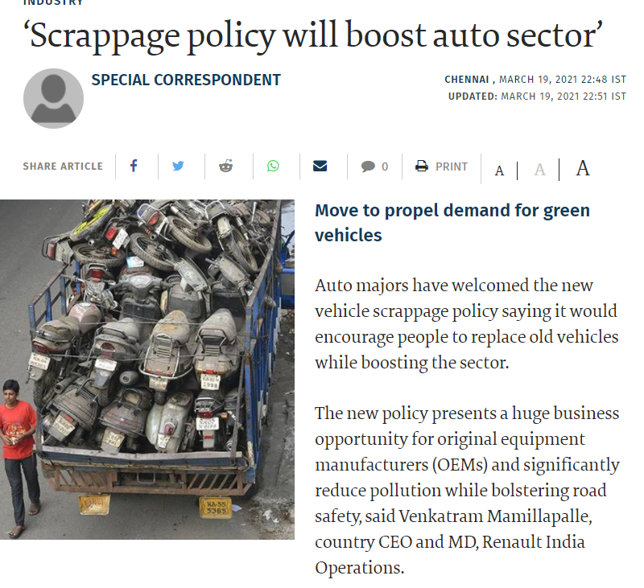

* The recently announced automobile scrappage policy will provide much needed respite to the automobile industry as sales of vehicles across categories can get a boost as customers are incentive to scrap their old vehicles, according to industry experts.
* As per the new policy, commercial vehicles of more than 15 years and passenger vehicles of more than twenty years will have to be mandatorily scrapped if they don’t pass the fitness and emission tests. Also, government departments will also have to let go of their vehicles after they are used for fifteen years.

**TECHNOLOGY TRENDS**

* We will be making significant investments in a variety of consumer-focused digital technologies, ranging from tablet-based product guides to virtual reality (VR)-enabled applications with an eye to increasing customer engagement on the showroom floor.
* Digital Advertising - It's important to understand where consumers are researching about vehicles. Social media is an essential tool for any business, but for the automotive industry it is a chance to target specific buyers based on their research habits.
* Our intent is to update and improve the sales process that has not changed for the better part of a century.

**TOOLS**

* SELECTION MATRIX
* BUSINESS MODEL CANVAS
* LEAN MODEL

**SELECTION MATRIX**

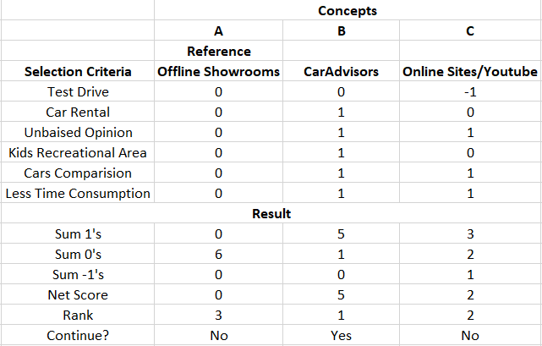

**BUSINESS MODEL CANVAS**

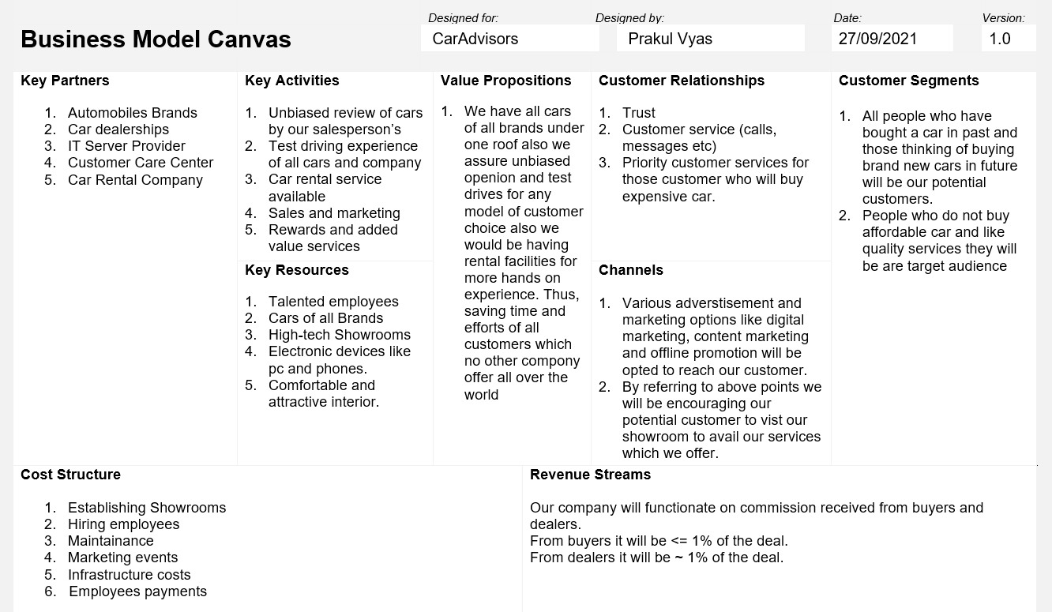

**LEAN MODEL**

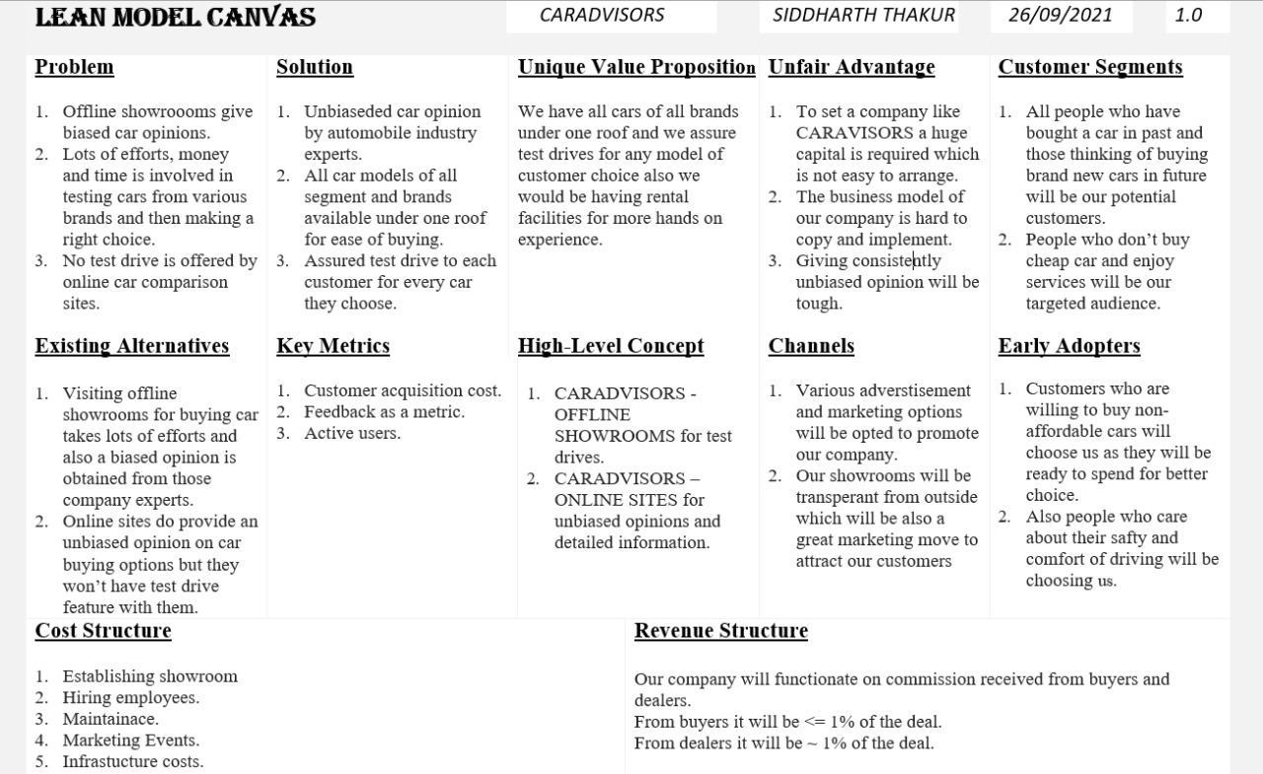

**REVIEW OF LITERATURE**

* 2013 Dr Ankur Kumar Rastogi and Nitin Gopal Gupta. The main purpose of this paper is to discuss the reasons for the slowdown in automobile industry. There is a huge scope for automobiles in India, but nowadays Indian automobile industry is facing a big problem, i.e., slowdown. It analyses the changing scenario of automobile industry that influence the purchasing behavior of consumers. It explains the sales analysis of various automobile companies in India. It also gives the scope for the future and highlights the solution with the help of new trends which should be adopted by the automobile companies to capture the market and increase the sales in future. It also throws the light on the new technologies for automobile sectors.
* 2015 Dr Kuldip Kaur and Neeraj Kumar The aim of the present study is to investigate the change in structure of Indian automobile industry the context of liberalization and globalization, which caused major changes in this industry. Automobile sector of emerging nations like China and India is growing at faster rate than developed countries. China’s automobile industry registered 16.92 per cent compound annual growth, followed by India 13.57 per cent. Whereas the developed nations like US and Germany lost their ground during that same period (1997-2013). The study also shows that the vehicle penetration is rising over the years in India. The situation was not good during 1990s but later on the situation started improving and in 2013 there were 31 motor vehicles available for 1000 persons.
* 2021 K. M. Kiran Raj & K. G. Nandha Kumar The automobile industry faces a significant problem due to slow down in economy/gross domestic product (GDP). The challenges faced by autonomous vehicles with reference to camera and processing of captured image/video processing are discussed. Analysis of automobile Sales/Production shows the connection between market and GDP/economy. . The study in this paper aims to analyses the market using sales/production data collected from the organization Internationale des Constructeurs d'Automobiles (OICA) across different regions, measures taken to overcome the recession caused by COVID-19 by analyzing similar situations and challenges faced in smart/autonomous vehicle.
* 2019 Smita Miglani This chapter analyzes the roles of government policy, infrastructure, and other enabling factors in the expansion of the automobile and automotive component sectors of India. In 2017, India became the world’s fourth largest automobile market, and the demand for Indian vehicles continues to grow in the domestic and international markets. To meet the future needs of customers (including the electrical vehicles) and stay ahead of competition, manufacturers are now catching up on upgradation, digitization, and automation. The chapter also analyzes India’s national policy in light of these developments. The growth of this sector has been on the back of strong government support which has helped it carve a unique path among the manufacturing sectors of India.
* 2017 Neelofar Kamal the Hon‟ble Prime Minister Mr. Modi in September 2014 as part of a wider set of nation -building initiatives. The programme has been devised to transform India into a global design and manufacturing hub. The automobile industry, along with the auto components industry, is one of the core industries in India. A well-developed transportation system plays a key role in the development of an economy, and India is no exception to it. Automobile is one of the largest industries in the global market. Owing to its strong forward and backward linkages with several key segments of the economy. Automobile Sector occupies a prominent place in the fabric of Indian Economy. The Make in India program was launched by Make in India is much more than an inspiring slogan. It represents a comprehensive and unprecedented overhaul of out -dated processes and policies.
* 2018 N.Chandrasekar and Dr V.R Palanivelu Automobile industry is one of the fastest developing industries in India. India stood at top 5th place globally in terms of automobile production in 2017. The study period was six years from 2012-13 to 2017-18. The study analyzed the trend and growth of automobile industry in India. The study found that total automobile production in India increased considerably during the study period. It was also noted that the growth rate of two wheelers was higher than other types of vehicles during the study period. Growth rate of commercial vehicles was lower than other types of vehicles. It was also found that total automobile export from India increased considerably during the study period.
* 2014 Dr C.Gopalakrishnan This paper investigates the Production, Domestic Sales and Export trends of the Indian automobile sector using the two financial years data from 2012-13 and 2013-14, and employ the findings to estimate the percentage changes in this sector. The study selected entire segments – two-wheelers (mopeds, scooters, motorcycles, electric two-wheelers), passenger vehicles (passenger cars, utility vehicles, multi-purpose vehicles), commercial vehicles (light and medium-heavy vehicles), and three wheelers (passenger carriers and good carriers).
* 2019 Nikita Arya in India, the automotive industry is one of the key drivers of the macroeconomic growth and technological advancement. This sector contributes 7.1% to the total GDP and provided employment to about 32 million people, directly and indirectly in the year 2016. The Government of India and the Indian automotive industry articulated their objectives for the future of the industry through the Automotive Mission Plan 2016-26 (AMP 2026). The plan envisions that by the year 2026, India will be among the top three in the world in engineering, manufacturing and export of vehicles and auto components. It is estimated that by 2020 the automobile industry in India will be the third largest in the World after China and USA. The paper aims at studying the performance and growth of India’s Automobile industry, the contributing factors for such growth and the present situation of foreign investments in this sector.
* 2020 Dr. Geetha Sivaraman the Pollution causes damage to the environment. Air pollution affects the life span of the living beings. The Government has imposed restrictions through various acts to control the pollution. There is continuous innovation in the car industry around the globe. Electric car is free from pollution, Tesla is an excellent example. The secondary data has been collected and analyzed to find out production and sales trend. Case study method has been followed. It reveals that there is a good sales turnover and 98% of produced electric passenger cars are sold. People started recognizing slowly the importance of environmentally friendly electric passenger vehicles.
* 2019 Dr N.MANICKKAVASAGAM and Mrs R.RADHIKA SIAM (society of Indian Automobile Manufacturers) has confirmed that Indian automakers are producing vehicles at 60-65% of their production capacity on an average. When the statistics of vehicle production is taken into consideration, a total of more than 29 million units were produced between April 2017 and March 2018. This includes commercial vehicles, passenger cars, two-wheelers, three-wheelers. The growth in production in the industry was 14.78% when compared to the same period the previous year. Industry experts are of the opinion that FY18 was a landmark in the history of automobile sales in India. This paper critically examines the growth and performance of Automobile Sector of India in order to get clear picture about the industry and its contribution.
* 2018 S. Senthil Vadivel and Dr M.Jayaprakasam this paper aims to find out the influencing factors on purchase decision of Motor Car. Primary data were collected from 485 car owners in Coimbatore District of Tamil Nadu. This study concluded that the factors namely brand with product aspects, service features, price with safety performance, Market trend and Technological features were considered buying decision of car. In addition, the manufacturers understand the responsible factors on buying decision of car.
* 2019 Aditya R. Gharge and Rashmi M. Pote A Business Intelligence software for an automotive dealer or an automotive company offers a comprehensive study of the market, the customers, potential customers etc. We can get an overview of all the sales outlets and departments, to make effective decisions based on logical and clear indicators.
* 2021 Kritika Anuragi and Akshay Raj and Smriti Bajpai From the onset of 2019, the industry dynamics were influenced by a series of external factors such as policy changes, increased taxes, higher interest rates, fuel price hikes and legal rulings that impacted the customers buying behaviors and delayed their purchase decisions. As a result, a reduced number of people are investing in automobiles pushing the industry towards a slowdown. In the thick of this downturn, Kia Motors ventured into the industry with Kia Seltos. It managed to have explosive sales with the launch and was able to sustain these numbers.  This research investigates and analyses the factors that were catalytic to Kia’s successful entry and Kia’s rise to being one of the top five carmakers of India dominating the Mid-SUV segment. The objective of the study is to highlight the major elements that drive customer’s buying behavior and to use them as a base to compare Kia’s products and services with that of its competitors. A thorough understanding of the factors that made the difference for Kia will help companies to improve their strategies, products and services.
* 2019 Bishwajit Pal, Dr.Samitha Khaiyum and Dr. Y. S. Kumaraswamy Autonomous vehicles will be getting mass acceptance in near future and is one of the biggest computer science dream to come true. But AV is also riddled with numerous issues in its design, implementation and practicality. In this paper we will be comparing existing autonomous vehicles and upcoming vehicles and compare them on their deployed vehicles in market, its intelligence to handle different types of problems, total miles driven and failure while in autonomous mode. Miles ridden to learn the AI, Range & Resolution of LIDAR, other sensors, Traffic sign recognition, complicated road with traffic handling. Software framework used, Computation hardware platform used and total computational strength.
* 2018 DR. NEELAM GOEL India is now the sixth largest manufacturer of cars in the world, making nearly four million cars a year and in Asia is third behind Japan and South Korea. No other car in recent times has created the sensation the Renault Duster has done in the Indian automotive industry. This predominantly European car has won over the Indian consumer. It has turbo-charged the compact sport-utility vehicle segment and revived the fortunes of Renault India. The Duster's success is more of a marketing achievement than the result of engineering excellence. Renault's strategy indicates a coming of age for the car industry in India with focus on customer-centric product development and use of consumer insights to drive engineering.
* 2018 Anoop R Ohri and Dr. Sandhir Sharma The objective of the present research is to investigate the previous studies conducted on the sources of online information mediums used by consumers at the pre-purchase stages of decision making, and the role of online information in pre-purchase decision making process in new passenger car industry. The paper finds that consumers gather large amount of information from digital media and they find it more convenient to compare the different brands of cars on digital channels rather than on old methods of information. Based on the findings from the literature, a conceptual model is proposed on the sources of online information used during search and evaluation stages in buying process for new passenger cars.

**PRODUCT PROTOTYPE**

1. **EXTERIOR VIEW**

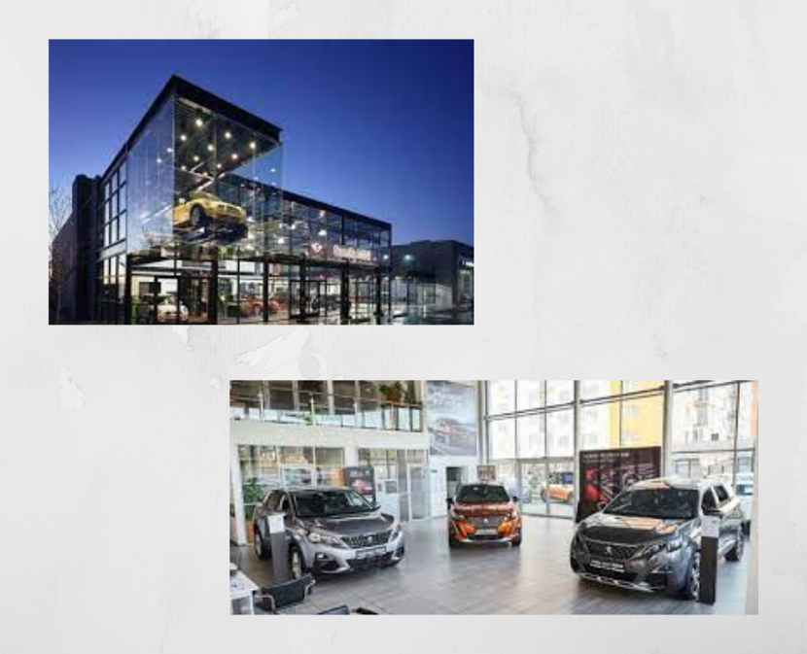

1. **INTERIOR VIEW**

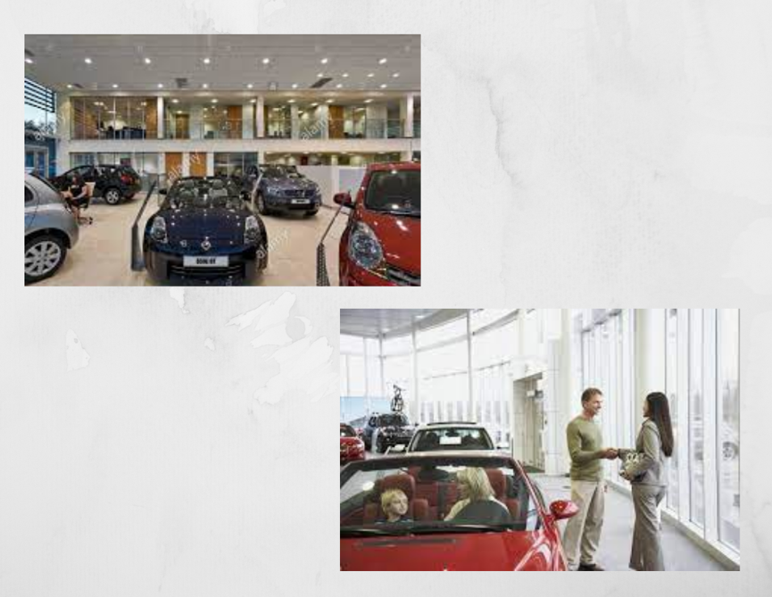

1. **CARS SEGREGATION BY SEGMENT**

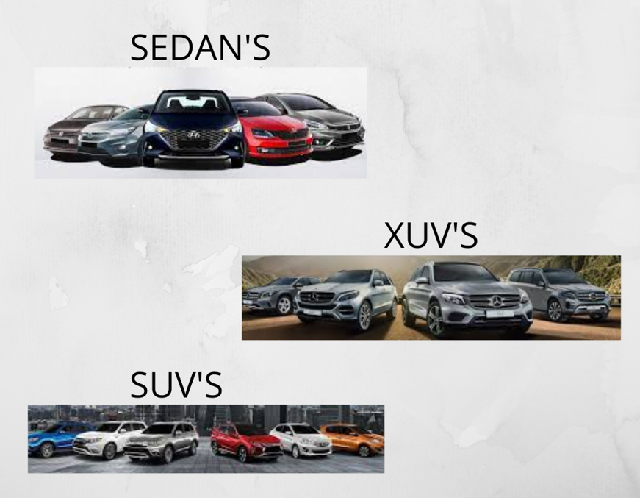

1. **CARS SEGREGATION BY PRICE**

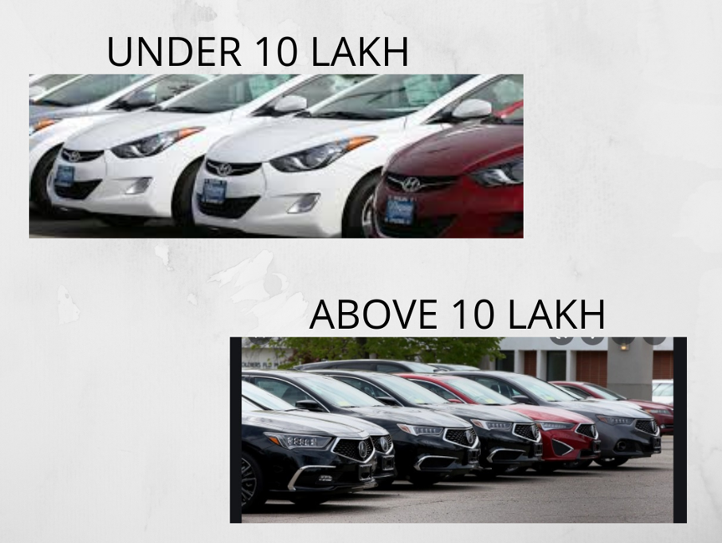

1. **KIDS RECREATIONAL AREA**

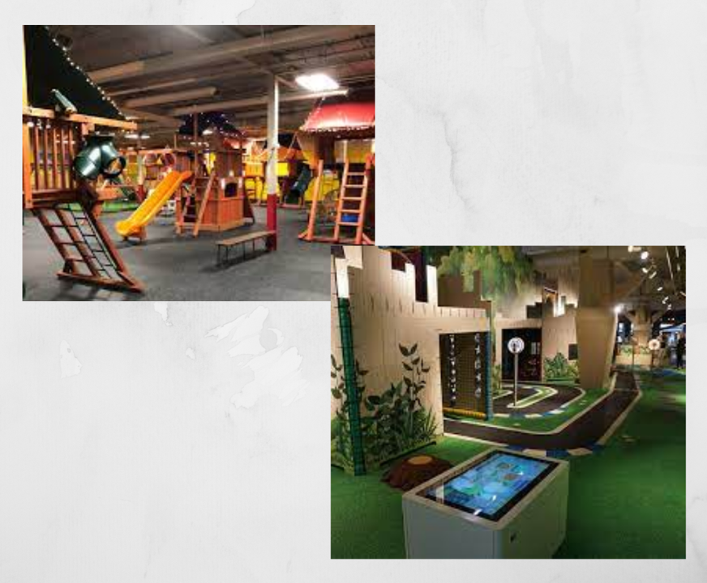

**MINIMUM VIABLE PRODUCT**

* **QUANTITATIVE ANALYSIS:**

1. We will be opening multi stored showrooms where various facilities will be provided to customers to get a better car buying experience. The cost of maintaining such showrooms and running them would be our major expense.

2. Also we will be charging commission on every car deals we make between dealers and customers so that will be our main source of income.

3. However our Net Product Value might be negative in initial years of business as we will be spending more than earning, but in longer run we can be profitable and also acquire a position NPV.

* **QUANTITATIVE ANALYSIS:**

1. We will be opening multi stored showrooms where various facilities will be provided to customers to get a better car buying experience. The cost of maintaining such showrooms and running them would be our major expense.

2. Also we will be charging commission on every car deals we make between dealers and customers so that will be our main source of income.

3. However our Net Product Value might be negative in initial years of business as we will be spending more than earning, but in longer run we can be profitable and also acquire a position NPV.

**BUDGET**

1. **SENSITIVE ANALYSIS**

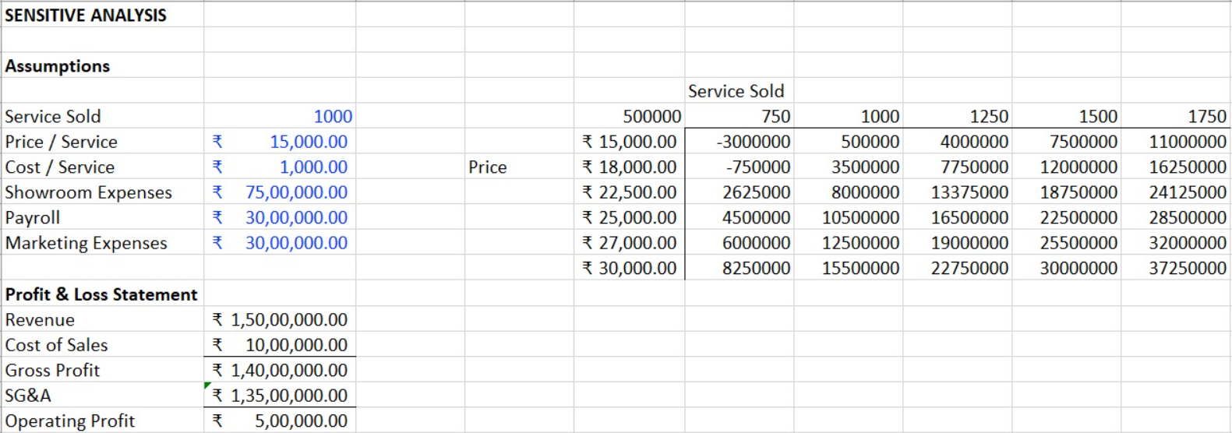

1. **NET PRESENT VALUE**

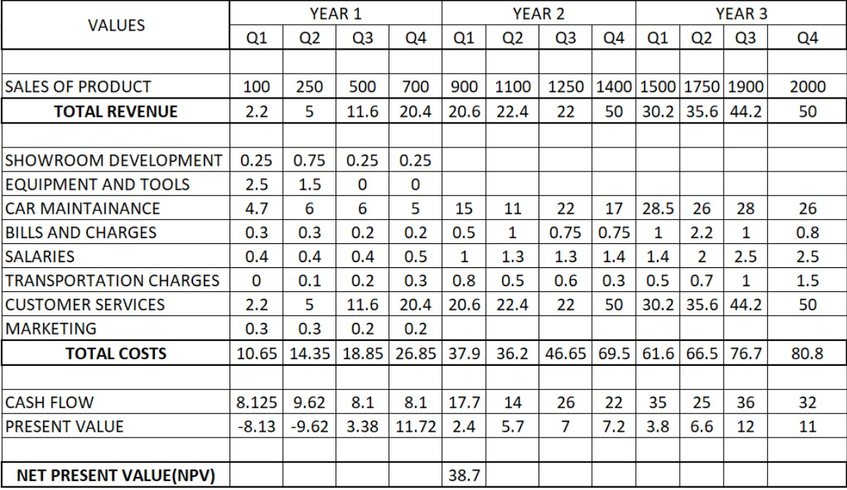

**FUNDING PLAN**

We CARADVISORS will be following series funding. Funding and fundraising, both are fundamental modern business scenarios that support the growth of a start-up. The first round of funding, popularly known as seed funding forms the basis of fundraising. It is followed by series A, B and C rounds of funding. While the seed funding typically refers to the basic, initial round of funding, series A, B, and C differ in the business maturity and the type of investors involved.

The series funding helps in the evolvement of a startup to a full-fledged organization by helping it with calculated funds at crucial steps.

1. Seed capital. The sum necessary to start the company and implement the idea in an MVP or prototype.
2. Series A. Early-stage funding that secures product optimization based on first adopters' and investors' feedback.
3. Series B. First positive results enable the next fundraising round to secure the money necessary for extending the potential of the project.
4. Series C and beyond. Once the project gains traction and shows significant results, we can secure funds necessary for further scaling to increase the revenue.

**FUNDING OPTIONS**



* Angel Investors are typically high net worth individuals who look to put relatively small amounts of money into start-ups’, typically ranging from a few thousand dollars to as much as a million dollars. However, their funding budgets are usually limited and sometimes cannot cover start-up needs in full. This fundraising strategy is best suited for getting seed capital and early-stage funding (Series A). it is important to remember that Google, Yahoo, and even Alibaba were a result of Angel investing.
* Venture Capitalists usually look for startups with a good enough traction and a strong team. This fundraising strategy is more viable for established companies that have already gained a foothold in the market.

**COST AND REVENUE**

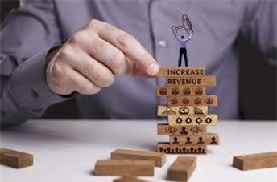

* **Expenses**

Accounting/Book-Keeping  
 Legal/Insurance fees  
 Infrastructure Costs  
 Office Rent  
 Utility Bills  
 Phone Bills/Mobile Phone/ Internet Costs  
 Advertising & Marketing  
 Salaries

* + **Revenue**
    - From Buyers
    - From Dealers

**MARKETING PLAN**

Marketing in business is key to its growth.

* **Email Marketing**

[Email marketing](https://mailchimp.com/email-marketing/) is an effective way to build a relationship with our audience and keep them engaged over time. Sharing updates about our services, content, products, and anything else that might be of interest to our potential customers.

* **Social media**

As social media usage worldwide continues to grow creating and scheduling post across channels, posting directly, or creating ads, social media can quickly communicate with anyone. [Facebook](https://mailchimp.com/marketing-glossary/facebook-ads/)**and**[Instagram ads](https://mailchimp.com/marketing-glossary/instagram-ads/)**:** Facebook and Integral each have more than a billion users worldwide, we can target specific segments of people with ads for CARADVISORS. like folks who live in a particular location or are within a certain age range.

* **Content marketing**

Content marketing focuses on creating (and sharing) content like blog posts, articles, videos, podcasts, and info graphics for our target audience. Content marketing can prove to be a cost-effective tactic that leads to big benefits for our business. Content marketing isn’t just about [selling](https://mailchimp.com/resources/how-to-sell/); it will provide relevant, valuable information which people care about—and actually want to engage with.

* **Offline promotion**
  + Create business cards or brochures

Physical items like business cards and brochures are a direct, convenient way to make a great first impression and tell new folks what we have to offer. Design and print professional business cards with the name of our business, our contact information and our logo.

* + Get people talking

When people hear that their co-workers, friends, or family members had a great experience with our services, there’s a good chance they’re going to give us a try, too.

**CUSTOMER CENTRIC**

* **UNIQUE VALUE PROPOSITION -** We have all cars of all brands under one roof, we assure unbiased opinion and test drives for any model of customer choice also we would be having rental facilities for getting more hands on experience. Thus, saving time and efforts of all customers which no other company offer all over the world.
* **CUSTOMER SEGMENTS**
  + All people who have bought a car in past and those thinking of buying brand new cars in future will be our potential customers.
  + People who do not buy affordable cars and like quality services, they will be our target audience.

**SWOT ANALYSIS**

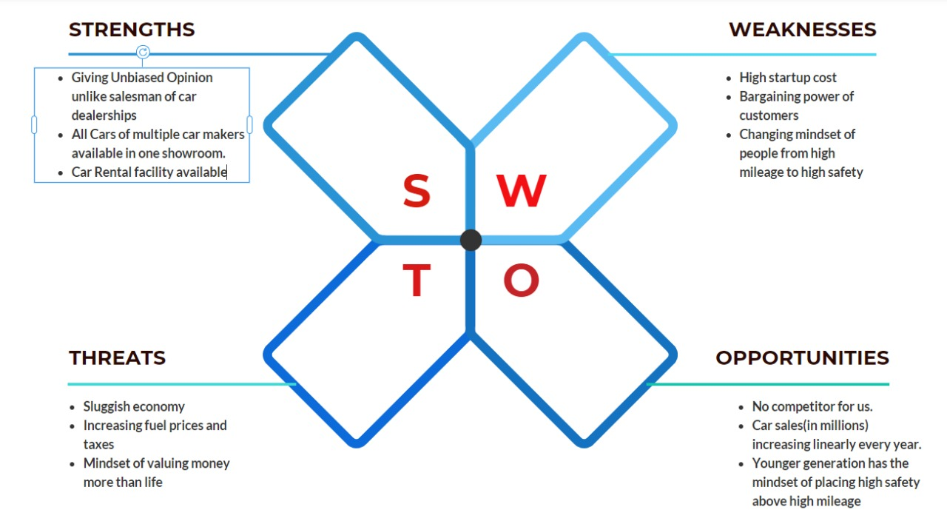

**COMMERCIAL**

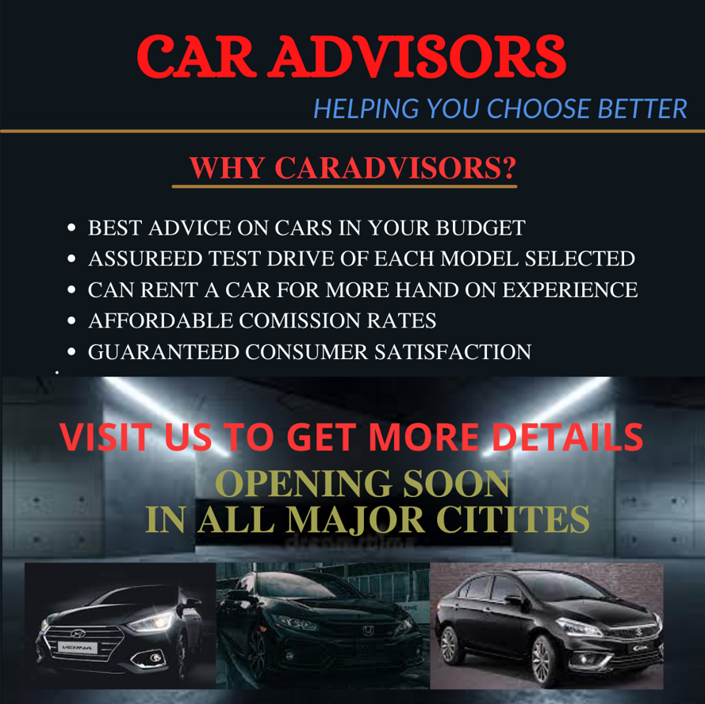

**VISION AND MISSION**

* **VISION**
  + To have only the best cars available in each segment running on roads.
* **MISSION**
  + Providing every information and hassle-free car buying experience to the customers they deserve.

**CONCLUSION**

* India accounts for 11 per cent of the global death in road accidents, the highest in the world. The country accounts for about 4.5 lakh road crashes per annum, in which 1.5 lakh people die. India tops the world in road crash deaths and injuries. It has 1 per cent of the world's vehicles but accounts for 11 per cent of all road crash deaths, witnessing 53 road crashes every hour; killing 1 person every 4 minutes,
* According to NCAP(an organization that conduct tests to evaluate cars on the basis of safety) Tata Nano, Alto 800, Maruti Swift, Hyundai i10, Datsun Go etc., failed NCAP tests and were declared to have high probability of life-threatening injuries and damages in case they meet with an accident.
* As our Mission and Vision states, we want to decrease death rates across the world (especially India) by guiding customers about safer cars by stressing on NCAP ratings, giving detailed unbiased information about all cars and enhance the car buying experience for all customers by reducing their efforts and money spent.

**BIBLIOGRAPHY**

* <https://timesofindia.indiatimes.com/>
* <https://en.wikipedia.org/wiki/Main_Page>
* <https://www.mindtools.com/>
* <https://docs.google.com/forms/u/0/>
* <https://www.renesas.com/us/en/application/automotive/car-information-systems>
* <https://www.autocarindia.com/>
* <https://ctb.ku.edu/en/table-of-contents/assessment/assessing-community-needs-and-resources/swot-analysis/main>
* <http://productdesignmanagement.com/what-is-product-design-management/>
* <https://mjl.clarivate.com/search-results>
* <https://www.scopus.com/home.uri>
* <https://www.newspapers.com/>
* <https://journalsuggester.springer.com/>
* The Design of Everyday Things, by Don Norman
* UX for Lean Startups, by Laura Klein